**Department of Electrical and Electronic Engineering**



Embedded Systems Project 2023-24

DESIGN REPORT #1

Title: **DR1--Motors**

Group Number: 5

|  |  |  |
| --- | --- | --- |
| Group members: | ID Number | I confirm that this is the group’s own work. |
| Vincent Vanhegan |  |  |
| Diego Roth |  |  |
| Parimal Saha |  |  |
| Zike Xu |  |  |
| Hongzhe Cai | 11041996 |  |

Tutor: Wuqiang Yang

Date: Click here to enter a date.

Contents

1. Introduction 1

2. Motor characterisation 1

3. Load measurements 1

4. Gear ratio selection 2

5. Summary 2

6. References 2

# Introduction

The first design report is all related to the motor in the robot buggy and the body part of the report is focusing on how to choose a proper gearbox by several experiment steps. This report will also briefly mention the signals using in the microcontroller to control the motor drive board.

During the experiment, the laboratory work involved tasks such as evaluating the resistance of power supply leads, analyzing the motor's performance under varying loads, estimating kinetic energy and torque constants, and determining the force required to propel the buggy on diverse surfaces while considering different weights. We got several pairs of data in the lab to support our estimate of the proper gear ratio.

Throughout the project's duration, the most important task we were talking about is the performance of the motor and the influences of the gearbox in the whole project. The choice of gearbox mainly affects the robot buggy’s speed and operational frequency. There are quite a lot of advantages and disadvantages for the gearbox. A well-designed gearbox with a proper gear ratio enables precise control over the robot buggy's speed and torque on varying terrains. Also, varying the gear ratio can help the robot buggy perform well on different scenarios. However, designing a perfect gearbox is very complex which needs several experiments and data to support, also it would have a huge cost.

Outside the experimental hours, we are also considering the signals needed to be used between the microcontroller and the motor drive board. We might employ the Pulse Width Modulation (PWM) on the motor drive board to regulate motor speed. PWM achieves this by rapidly alternating the voltage supply, effectively managing the motor's average voltage. If necessary, the PWM signal from the microcontroller can be transformed into an analog voltage by a low-pass filter.

# Motor characterisation

**Introduction**

During our motor characterisation investigation, our goal is to calculate the torque constant, KE, and the voltage constant, KE, which enable us to respectively

determine the relationships between torque and current as well as voltage and angular speed. Along the way we shall also obtain some other values for the motor to assist in our calculations, we shall do this by measuring the voltage, current and torque of our motor in various setups to gauge and check these obtained values. We do still need to keep within the operating limits of the motor, to avoid damage or overheating, so Voltage will be limited to 5V and current to 1.4 A.

**Test 4:**

Now when stalling the motor, we vary the current measuring the terminal voltage of the motor and the required stall force.

**Experimental setup:**

The graph in figure 1 shows the linearity of the motor’s relationship between voltage and current, which is consistent with prior test.

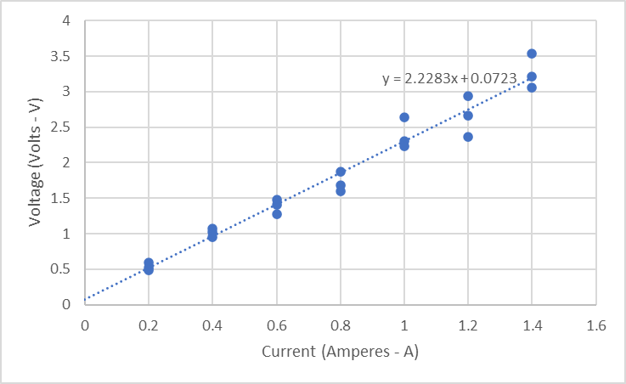

|  |
| --- |
| *Figure 1a - Graph Showing Voltage-Current characteristics of a motor when stalled* |

# Load measurements

Load measurements • How does this section relate to each other/the whole report/aim/objectives? • Estimated forces required to drive the buggy up the slope, with all measurements and justification. • Estimated forces required to drive the buggy on the flat, with all measurements and justification. • Required torque at the wheel shafts, with any measurements, assumptions and calculations.

* See the chapter on Reports (near the start of the ESP Procedures Handbook).
* See the specific marking scheme for this section of the report.

# Gear ratio selection

• How does this section relate to each other/the whole report/aim/objectives? • What current/voltage would you need to get the buggy up the maximum incline using the given motors and no gearbox? • Available motor torque with the constraints of the given motor and drive board, with any assumptions and calculations. • Use your measurements of available motor torque and the torque required to move your buggy up the slope to determine the required gear ratio. This should take into account the efficiency of the gearbox. • Which of the available gearboxes you will use and calculate the required position of the intermediate shaft as an (x,y) coordinate. • For the selected gearbox use your measurements to calculate the expected maximum speed of your buggy on the ramp and on the flat. • Your report should clearly show the steps involved in the above.

* See the chapter on Reports (near the start of the ESP Procedures Handbook).
* See the specific marking scheme for this section of the report.

# Summary

• Summarise: what the report was for, your assumptions, and key findings including values. • Discuss any points of interest • Conclude with design recommendations, explicitly stating your chosen gearbox.

* Design recommendations
* Summary of key results and assumptions.

# References

1. See the section on Citations and Referencing Styles in the ESP Procedures Handbook.

Make sure that you have **read the top** of the marking scheme to look for report length etc.

Make sure that you have **read the bottom** of the marking scheme for Presentation and Penalties.

Remember to update your table of contents before submitting the report.

Aim to submit the report long before the deadline, to mitigate last minute problems with the internet and with Blackboard.